Parth Shukla
190905104
Lab 2

1) Write a C program to emulate the ls -l UNIX command that prints all files in a current directory and lists access privileges, etc. DO NOT simply exec ls -l from the program.

#include <unistd.h>
#include <stdio.h>
#include <stdlib.h>
#include <sys/stat.h>
#include <sys/types.h>
#include <dirent.h>

int main(){
DIR * dp;

struct dirent * entry;

struct stat statbuf;
if((dp = opendir(".")) == NULL){
printf("Cannot open directory \n");
exit(1);
}

chdir(".");

while((entry = readdir(dp)) != NULL){

lstat(entry->d_name,&statbuf);

if(!S_ISDIR(statbuf.st_mode)){
printf("%s \t \t",entry->d_name);
printf((S_ISDIR(statbuf.st_mode)) ? "d" : "-");
printf((statbuf.st_mode & S_IRUSR) ? "r" : "-");
printf((statbuf.st_mode & S_IWUSR) ? "w" : "-");
printf((statbuf.st_mode & S_IXUSR) ? "x" : "-");
printf((statbuf.st_mode & S_IRGRP) ? "r" : "-");
printf((statbuf.st_mode & S_IWGRP) ? "w" : "-");
printf((statbuf.st_mode & S_IXGRP) ? "x" : "-");
printf((statbuf.st_mode & S_IROTH) ? "r" : "-");
printf((statbuf.st_mode & S_IWOTH) ? "w" : "-");
printf((statbuf.st_mode & S_IXOTH) ? "x" : "-");
printf("\n");
}
}
}

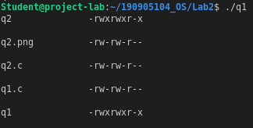

2) Write a program that will list all files in a current directory and all files in subsequent subdirectories.

#include <unistd.h>
#include <stdio.h>
#include <stdlib.h>
#include <sys/stat.h>
#include <sys/types.h>
#include <dirent.h>
#include <string.h>

void printdir(char* path, int depth){
DIR * dp;
struct dirent * entry;
struct stat statbuf;

if((dp = opendir(path)) == NULL){
printf("Could not open directory\n");
exit(1);
}

chdir(path);

while((entry = readdir(dp)) != NULL){
lstat(entry->d_name, &statbuf);
if(S_ISDIR(statbuf.st_mode)){
// found sub directory
if(strcmp(".", entry->d_name)==0 || strcmp("..", entry->d_name) == 0){
continue;
}

printf("%*s%s/\n",depth,"",entry->d_name);
printdir(entry->d_name, depth+4);

}

else{
printf("%*s%s\n",depth,"",entry->d_name);
}

}

chdir("..");

closedir(dp);
}
int main(){
printdir(".", 0);
return 0;
}

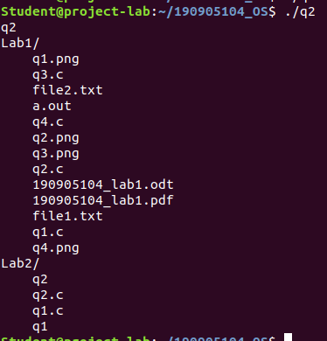

3) How do you list all installed programs in Linux?

dpkg -l

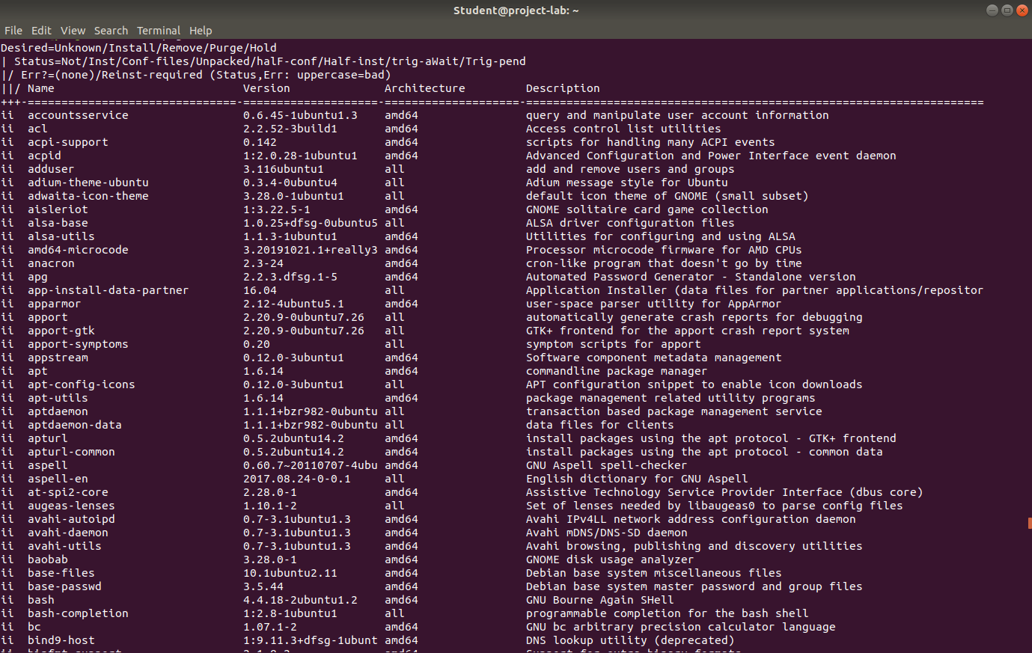

4) How do you find what RPM packages are installed?

Installed RPM using sudo apt install rpm
After that,
rpm -qa

